**Your Topic Title**

(Project report for *Introduction to Computing* [COMP111-11x])

MPILogo_green2.emf

**Group members:**

Chan Tai Man, Peter (P-1x-0aaa-a)

Li Ho Mei, Mary (P-1x-0bbb-b)

Yan Jiabo, Leo (P-1x-0ccc-c)

1st Semester, 2019-2020

**Table of Contents**

[§1. Overview 1](#_Toc433025487)

[1.1. Introduction 1](#_Toc433025488)

[1.2. Intellectual Property Rights 1](#_Toc433025489)

[1.3. Common Types 1](#_Toc433025490)

[1.4. Pros and Cons 1](#_Toc433025491)

[§2. Copyright 1](#_Toc433025492)

[2.1. Definition 1](#_Toc433025493)

[2.2. Copyright Owner’s Rights 2](#_Toc433025494)

[2.3. Copyright Ordinance of Macao 2](#_Toc433025495)

[§3. Trademark 2](#_Toc433025496)

[3.1. Definition of Trademark 2](#_Toc433025497)

[3.2. Trademark Ordinance of Macao 2](#_Toc433025498)

[3.3. Xxx Yyy 2](#_Toc433025499)

[§4. Patent 3](#_Toc433025500)

[4.1. What is a Patent? 3](#_Toc433025501)

[4.2. Term of Invention Patent 3](#_Toc433025502)

[4.3. Short-Term Patent vs. Standard Patent 3](#_Toc433025503)

[§5. Issues of Concern 3](#_Toc433025504)

[5.1. Basic Problems 3](#_Toc433025505)

[5.2. Analysis of Problems 3](#_Toc433025506)

[§6. Conclusion 3](#_Toc433025507)

[§7. References 3](#_Toc433025508)

# Overview

## Introduction

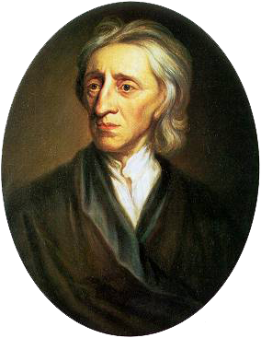

John Locke

Intellectual Property: any unique product of the human intellect that has commercial value ...

John Locke on notion of property right: people have a right to ...

## Intellectual Property Rights

Intellectual property rights protection stimulates ...

Intellectual property rights protection may interfere ...

In March 2004, European regulators ordered Microsoft to remove its Media Player software from its *Windows* operating system and pay the fine of €49xxxxxxx …

Microsoft paid the fine in full in ...

Society benefits the most when inventions are in the public domain ...

IP laws provide a balance between the benefits of IP creators and ...

## Common Types

* Copyright
* Trademark
* Service mark
* Patent
* Trade secret

## Pros and Cons

### Advantages

* Advantage 1
* Advantage 2
* Advantage 3

### Disadvantages

* Disadvantage 1
* Disadvantage 2
* Disadvantage 3

# Copyright

## Definition

Copyright is also known as ...

Copyright is a property right subsisting in ...

Copyright does not subsist unless ...

In most places, including Macao and Hong Kong, a public register of copyright protected works is ...

## Copyright Owner’s Rights

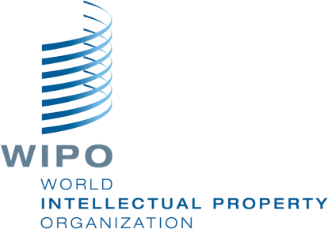The rights owner of a work can prohibit or authorize (Quoted from WIPO’s Understanding Copyright and Related Rights):

Its reproduction in various forms, such as ...

The distribution of copies ...

Its public ...

## Copyright Ordinance of Macao

Macao Emblem



The ordinance is available in Chinese and Portuguese only.

The link for the Chinese version is as follows.

[Decree-Law Nº. 43/99/M](http://bo.io.gov.mo/bo/i/99/33/declei43_cn.asp)

Copyright duration: 50 years after ...

# Trademark

## Definition of Trademark

In ...

By ...

As …

## Trademark Ordinance of Macao

A ...

B ...

C ...

## Xxx Yyy

A ...

B ...

# Patent

## What is a Patent?

In ...

By ...

## Term of Invention Patent

A ...

B ...

C ...

## Short-Term Patent vs. Standard Patent

A ...

B ...

C ...

# Issues of Concern

## Basic Problems

I ...

B ...

## Analysis of Problems

A ...

B ...

C ...

# Conclusion

The usage of ...

Overall speaking ...

# References

1. [Decree-Law Nº. 43/99/M (Copyright Ordinance of Macao – Chinese version)](http://bo.io.gov.mo/bo/i/99/33/declei43_cn.asp)
2. http://bo.io.gov.mo/bo/i/99/33/declei43\_cn.asp